EENG 385 - Electronic Devices and Circuits

Frequency Domain: Active Filters

How To: Build a Bode Plot Using Frequency Sweep Method

**How To: Audio Board, Bode Plot via FRA**

You will now draw the Bode plots of the filters using the test and measurement equipment to determine the magnitude and phase change of a low pass filter using the same point-by-point methods you used in MultiSim Live. While there are a lot of instructions, once you have everything properly setup, this process goes quick. In other words, don’t be intimidated by the length of the instructions.

As you saw with MultiSim Live, creating a Bode plot using the point-by-point method is time consuming, tedious, and prone to error. Also like Multisim Live, our oscilloscopes have a built-in function called frequency response analysis (FRA) that automatically builds a Bode plot for an electronic device. The process of using the FRA function is complicated by the fact that the oscilloscopes’ function generator cannot add a DC offset to the since waves sent to the device under test. Thus, you will have to use your level shifter to add a DC offset to the oscilloscopes function generator output prior to feeding the signals into your filters. To do this, following this configuration:

* Install female/female jumper wire between the OUTUT LEVEL to INPUT LPF pins,
* Install the female end of a male/female jumper wire onto the INPUT LEVEL pin,
* Install the female end of a male/female jumper wire onto the OUTPUT LPF pin,
* Adjust the level potentiometer to 2.0V,
* Connect a function generator coaxial cable to the function generator connector of the oscilloscope. This connector is just above the power button.
* Attach the black ground clip of the coaxial cable to a ground loop,
* Attach the red clip of the coaxial cable to the INPUT LEVEL male end of the jumper wire,
* Attach the black ground clip of the oscilloscope probe to a ground loop on the Audio board,
* Configure your oscilloscope as follows:

When you have everything setup, compare your setup to that shown in Figure 1.

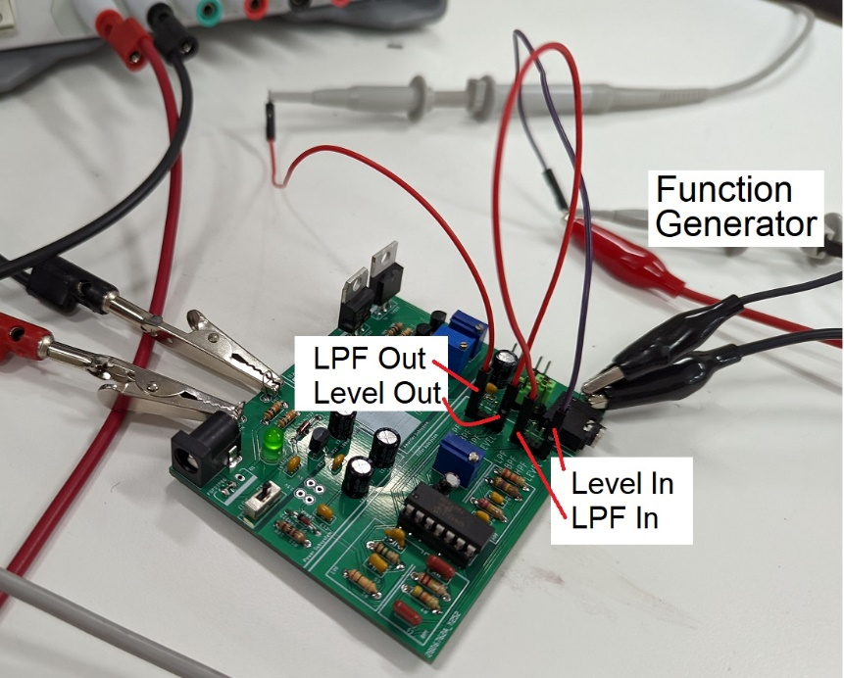

Figure 1: The correct hardware setup to use the FRA capability of the oscilloscopes.

Once you have verified that your board is configured correctly, it’s time to use the FRA function to generate a Bode plot for your filter.

* Press the Analysis button (just above the Ch2 vertical scale knob)
* Press the Features softkey and select FRA
* Make sure the setup tab (gear icon) is selected
  + Frequency Mode Sweep
  + Frequency (Start, Stop) 10Hz 47kHz
  + Points per decade 10
  + Source (Input, Output) 1 2
  + WaveGen 200mVpp 50Ω
* Press Run Analysis. The screen displays the input and output waveform as data is bring collected.
* The graph tab should auto select and display the Bode Plot for the audio amplifier similar to the one shown in Figure 2.

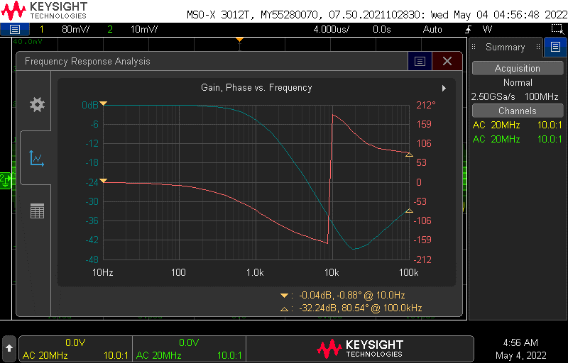

Figure 2: The Bode plot generated by the FRA tool of the Infinivision 3012T oscilloscope.

To save the image on the screen

* + [Save/Recall] → Save → Format → 24-bit Bitmap image (*.bmp)
  + [Save/Recall] → Save → Press to Save